**Lab – 50: Download and install the ATA Gateway setup package?**

**Objective:** The objective of this lab is –

* To download and install the ATA Gateway setup package.

After configuring the domain connectivity settings, you can download the ATA Gateway setup package. The ATA Gateway can be installed on a dedicated server or on a domain controller. If you install it on a domain controller, it is installed as an ATA Lightweight Gateway.

**Prerequisite:** Windows Server 2016. Windows server should be a member of a domain or workgroup. At least one network adapter. Microsoft .Net Framework 4.6.1 or later. Browser - Internet Explorer version 10 and above (or any other latest browser).

**Steps:**

1. Click **Download Gateway** Setup in the list of steps at the top of the page to go to the **Gateways** page.

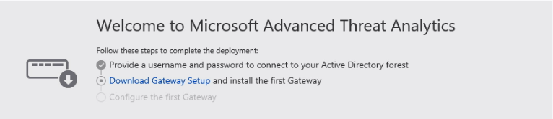

1. Click **Gateway Setup** and save the package locally.

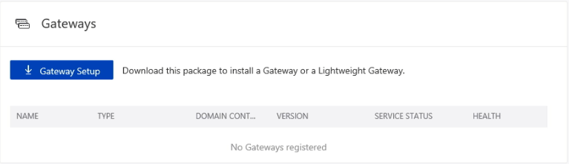

1. Extract the zip file that includes - ATA Gateway installer and Configuration setting file with the required information to connect to the ATA Center.
2. Now to install, run **Microsoft ATA Gateway Setup.exe** and follow the setup wizard. On the **Welcome** page, select your language and click **Next**.

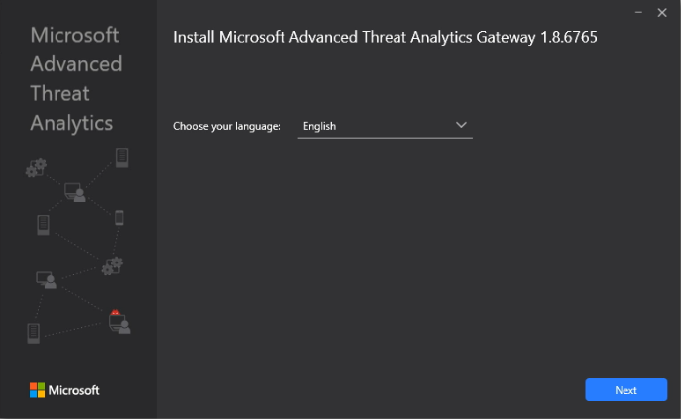

1. The installation wizard automatically checks if the server is a domain controller or a dedicated server. If it is a domain controller, the ATA Lightweight Gateway is installed, if it is a dedicated server, the ATA Gateway is installed.
2. Then click **Next**.

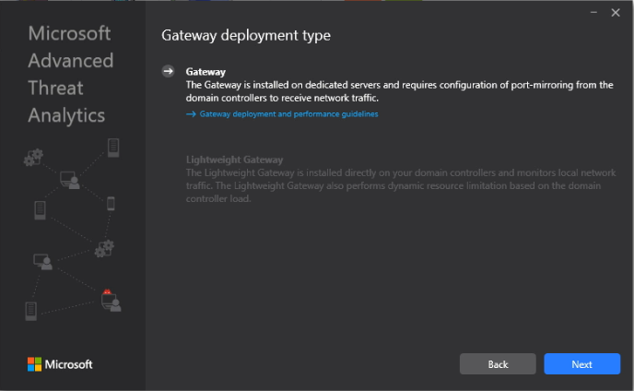

1. Under **Configure the Gateway**, enter the information based on your environment – Installation path.

**Installation Path-** This is the location where the ATA Gateway is installed. By default, this is %programfiles%\Microsoft Advanced Threat Analytics\Gateway. Leave the default value.

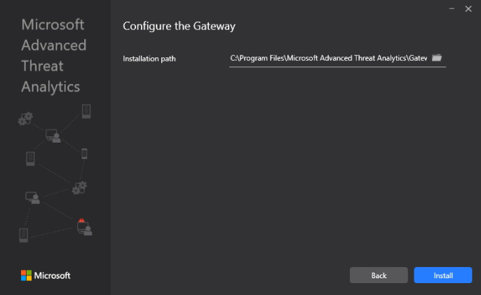

1. Now click **Install**. The components installed and configured during the installation of the ATA Gateway are - ATA Gateway service, Microsoft Visual C++ 2013 Redistributable and Custom Performance Monitor data collection set.

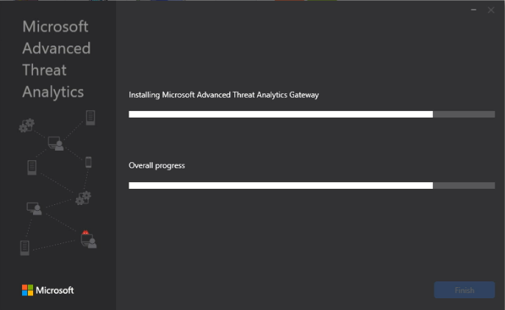

1. After the installation completes, for the ATA Gateway, click **Launch** to open your browser.

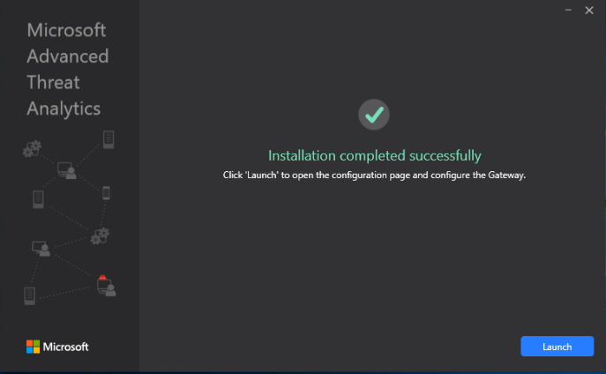

1. Log into the ATA console.

